|  |  |
| --- | --- |
| Project Title | **Data Analyst Jobs** |
| Tools | ML, Python, SQL, Excel |
| Domain | Finance Analyst |
| Project Difficulties level | intermediate |

Dataset : Dataset is available in the given link. You can download it at your convenience.

[Click](https://drive.google.com/drive/folders/1Yl2rAwytABKjF1SOabxMe7civ0z1FBNI?usp=sharing) [here](https://drive.google.com/drive/folders/1Yl2rAwytABKjF1SOabxMe7civ0z1FBNI?usp=sharing) [to](https://drive.google.com/drive/folders/1Yl2rAwytABKjF1SOabxMe7civ0z1FBNI?usp=sharing) [download](https://drive.google.com/drive/folders/1Yl2rAwytABKjF1SOabxMe7civ0z1FBNI?usp=sharing) [data](https://drive.google.com/drive/folders/1Yl2rAwytABKjF1SOabxMe7civ0z1FBNI?usp=sharing) [set](https://drive.google.com/drive/folders/1Yl2rAwytABKjF1SOabxMe7civ0z1FBNI?usp=sharing)

Amidst the pandemic many people lost their jobs, with this dataset it is possible to hone the job search so that more people in need can find employment.

This dataset was created by [picklesueat](https://github.com/picklesueat/data_jobs_data) and contains more than **2000 job listing for data analyst** positions, with features such as:

* Salary Estimate
* Location
* Company Rating
* Job Description ● and more.

# How to use

* Find the best jobs by salary and company rating
* Explore skills required in job descriptions
* Predict salary based on industry, location, company revenue ● Your kernel can be featured here!
* [Data](https://www.kaggle.com/andrewmvd/data-engineer-jobs) [Engineer](https://www.kaggle.com/andrewmvd/data-engineer-jobs) [Jobs](https://www.kaggle.com/andrewmvd/data-engineer-jobs)
* [Business](https://www.kaggle.com/andrewmvd/business-analyst-jobs) [Analyst](https://www.kaggle.com/andrewmvd/business-analyst-jobs) [Jobs](https://www.kaggle.com/andrewmvd/business-analyst-jobs)
* [Data](https://www.kaggle.com/andrewmvd/data-scientist-jobs) [Scientist](https://www.kaggle.com/andrewmvd/data-scientist-jobs) [Jobs](https://www.kaggle.com/andrewmvd/data-scientist-jobs)
* [More](https://www.kaggle.com/andrewmvd/datasets) [Datasets](https://www.kaggle.com/andrewmvd/datasets)

**Acknowledgements**

If you use this dataset, please [support](https://github.com/picklesueat/data_jobs_data) [the](https://github.com/picklesueat/data_jobs_data) [author](https://github.com/picklesueat/data_jobs_data).

**License**

License was not specified at the source

**Splash banner**

Photo by [Chris](https://unsplash.com/@chrisliverani?utm_source=unsplash&utm_medium=referral&utm_content=creditCopyText) [Liverani](https://unsplash.com/@chrisliverani?utm_source=unsplash&utm_medium=referral&utm_content=creditCopyText) on [Unsplash](https://unsplash.com/photos/NDfqqq_7QWM)

**Splash Icon**

Icon by [Eucalyp](https://www.flaticon.com/authors/eucalyp) available on [flaticon.com](https://www.flaticon.com/free-icon/businessman_1465883?term=data%20analyst&page=1&position=9)

# Example: You can get the basic idea how you can create a project from here

|  |
| --- |
| **Step 1: Problem Definition**  **Objective**   * Analyze trends in data analyst job postings. * Predict salary ranges for given job attributes. * Provide insights into company ratings, locations, and industry trends.   **Input Columns**   * **Job Title**: Position name. * **Salary Estimate**: Predicted/actual salary. * **Job Description**: Text describing responsibilities. * **Rating**: Employer rating. * **Company Name**: Employer name. * **Location**: Job location. * **Headquarters**: Company HQ location. * **Size, Founded, Type of ownership**: Company metadata. * **Industry, Sector, Revenue, Competitors**: Market details. * **Easy Apply**: Indicates if the job has a one-click application option.   **Step 2: Data Collection**  Assume data is in a CSV file named data_analyst_jobs.csv. Load the data and  inspect.  **Code:** |

|  |
| --- |
| python  import pandas as pd  # Load the dataset data = pd.read_csv("data_analyst_jobs.csv")  # Inspect the dataset print(data.head()) print(data.info())  **Step 3: Exploratory Data Analysis (EDA)**  **Step 3.1: Overview**   * Check for duplicates. * Understand column distributions.   **Code:** python  # Check for duplicates print(f"Duplicate rows: {data.duplicated().sum()}")  # General statistics print(data.describe(include='all')) |

|  |
| --- |
| # Value counts for categorical columns for col in ['Job Title', 'Type of ownership', 'Industry', 'Sector']:  print(data[col].value_counts().head())  **Step 3.2: Visualization**  Use visualizations to explore data.  **Code: Salary Distribution** python  import matplotlib.pyplot as plt import seaborn as sns  # Salary distribution plt.figure(figsize=(10, 6)) sns.histplot(data['Salary Estimate'], kde=True, bins=20) plt.title("Salary Estimate Distribution") plt.xlabel("Salary") plt.show()  **Code: Ratings by Industry**  python |

|  |
| --- |
| plt.figure(figsize=(12, 6)) sns.boxplot(x='Industry', y='Rating', data=data) plt.xticks(rotation=90) plt.title("Company Ratings by Industry") plt.show()  **Step 4: Data Cleaning**  **Step 4.1: Handling Missing Values**   * Fill missing values with appropriate techniques. * Drop columns with excessive missing data.   **Code:** python  # Check missing values print(data.isnull().sum())  # Fill missing numerical values data['Rating'].fillna(data['Rating'].median(), inplace=True)  # Drop columns with > 30% missing data threshold = len(data) * 0.3 data = data.dropna(thresh=threshold, axis=1) |

|  |
| --- |
| # Forward-fill categorical values categorical_cols = ['Company Name', 'Industry', 'Sector', 'Type of ownership'] data[categorical_cols] =  data[categorical_cols].fillna(method='ffill')  **Step 4.2: Standardizing Data**  ● Extract numerical values from text (e.g., Salary Estimate).  **Code:** python  # Extract minimum salary data['Min Salary'] = data['Salary  Estimate'].str.extract(r'(\d+)').astype(float)  # Extract maximum salary data['Max Salary'] = data['Salary  Estimate'].str.extract(r'-\s*(\d+)').astype(float)  # Compute average salary data['Avg Salary'] = (data['Min Salary'] + data['Max Salary'])  / 2 |

|  |
| --- |
| # Drop old salary column  data.drop('Salary Estimate', axis=1, inplace=True)  **Step 5: Feature Engineering**  **Step 5.1: Text Analysis**  ● Process Job Description for keywords (e.g., Python, Excel).  **Code:** python  # Extract keywords from Job Description data['Python'] = data['Job Description'].str.contains('Python', case=False, na=False).astype(int) data['Excel'] = data['Job Description'].str.contains('Excel', case=False, na=False).astype(int)  # Create a tech skills score  data['Tech_Skills'] = data['Python'] + data['Excel']  **Step 5.2: Location Splits** python  # Extract city and state from location data['City'] = data['Location'].str.split(',', expand=True)[0] |

|  |
| --- |
| data['State'] = data['Location'].str.split(',', expand=True)[1]  **Step 6: Statistics**  **Analyze relationships using correlation and significance tests.**  **Code:** python  # Correlation matrix plt.figure(figsize=(10, 8)) sns.heatmap(data.corr(), annot=True, cmap="coolwarm") plt.title("Correlation Matrix") plt.show()  **Step 7: Model Development**  **Step 7.1: Data Splitting** Split into features and target: python  from sklearn.model_selection import train_test_split  # Define features and target |

|  |
| --- |
| features = ['Rating', 'Tech_Skills', 'Size', 'Founded'] X = data[features] y = data['Avg Salary']  # Train-test split  X_train, X_test, y_train, y_test = train_test_split(X, y, test_size=0.2, random_state=42)  **Step 7.2: Model Training**  Use Random Forest Regressor to predict salaries. python  from sklearn.ensemble import RandomForestRegressor from sklearn.metrics import mean_absolute_error, r2_score  # Train model model = RandomForestRegressor(n_estimators=100, random_state=42) model.fit(X_train, y_train)  # Predict y_pred = model.predict(X_test) |

|  |
| --- |
| # Evaluate mae = mean_absolute_error(y_test, y_pred) r2 = r2_score(y_test, y_pred) print(f"MAE: {mae}, R2 Score: {r2}")  **Step 8: Deployment**  **Deploy model using Streamlit or Flask.**  **Example:** python  import streamlit as st  st.title("Data Analyst Job Analysis") st.write("Average Salary Prediction")  # User input rating = st.slider("Company Rating", 1, 5, 3) tech_skills = st.slider("Tech Skills Score", 0, 2, 1) size = st.selectbox("Company Size", [0, 1, 2]) founded = st.number_input("Year Founded", min_value=1900, max_value=2023, value=2000)  # Predict |

|  |
| --- |
| prediction = model.predict([[rating, tech_skills, size, founded]]) st.write(f"Predicted Salary: ${prediction[0]:,.2f}") |

# Sample Code and output

|  |
| --- |
| import pandas as pd import numpy as np import matplotlib.pyplot as plt import seaborn as sns import warnings import re import plotly.graph_objects as go import plotly.express as px from plotly.subplots import make_subplots warnings.filterwarnings('ignore')  In [2]:  data_analyst_jobs =  pd.read_csv('/kaggle/input/data-analyst-jobs/DataAnalyst.csv')  3 Dataset Overview  The overview is prepared to get the feel on data structure. It will also include a quick |

|  |
| --- |
| analysis on missing values, basic statistics and data manipulation.  The dataset consists of the following information   * **Job Title** :A name that describes someone's job or position. * **Salary Estimate**: A display a range for annual base or hourly pay and are specific to Data Analytics Industry * **Job Description**: The plain-language tool that explains the tasks, duties, function and responsibilities of a position * **Rating** : Company Rating * **Company Name**: The name of the company * **Location**: The location where the job is available * **Headquarters**: The headquarters of the company * **Size**: The size of the employee * **Type of Ownership**: Type of ownership whether it is public, private or non-profit * **Industry**: Different industries where the job is available * **Sector**: Sector where the job is available ● **Revenue**: Company earnings annually. * **Easy Apply**: Easy Apply section * **Observations** * There are 2253 rows and 13 columns and 1 missing values.   *(to see the details, please expand)*  In [3]:  data_analyst_jobs = data_analyst_jobs.drop('Unnamed: 0',axis=1) data_analyst_jobs = data_analyst_jobs.drop('Founded', axis=1) data_analyst_jobs = data_analyst_jobs.drop('Competitors', |

axis

=

1

)

print

(

f

'Number

of

rows:

**{**

data_analyst_jobs

.

shape[

0

]

**}**

;Number

of

columns:

**{**

data_analyst_jobs

.

shape[

1

]

**}**

;

No

of

missing

values:

**{**

sum

data_analyst_jobs

(

.

isna()

.

sum())

**}**

'

)

Number

of

rows:2253;Number

of

columns:13;

No

of

missing

values:1

3.1

Quick

view

Below

is

the

first

5

rows

of

data

analyst

jobs

dataset:

In

[4]:

data_analyst_jobs

.

head()

Out[4]:

Job

Titl

e

Sal

ary

Esti

mat

Job

Descriptio

n

R

at

in

g

Comp

any

Name

Lo

ca

tio

n

Hea

dqu

arter

s

Siz

e

Typ

e

of

own

ersh

Ind

ustr

y

Sect

or

Re

ve

nu

e

E

a

s

y

A

|  |  |  |  |  |  |  |  |  |  |  |  |  |  |  |
| --- | --- | --- | --- | --- | --- | --- | --- | --- | --- | --- | --- | --- | --- | --- |
|  | | | | | | | | | | | | | | |
|  |  |  | e |  |  |  |  |  |  | ip |  |  |  | p p  ly |
| 0 | Dat a Ana lyst,  Ce  nter on Im mig  rati  on and Jus tic..  . | 37  K  −  37  K−  66  K  (Gl ass doo  r est.  ) | Are you eager to roll up your sleeves and harn... | 3.  2 | Vera  Institut e of  Justic e\n3.2 | Ne w  Yo rk,  N  Y | New  York  , NY | 201  to  500 em  plo yee s | Non profi t  Org  aniz atio  n | So  cial  Ass  ista nce | Non-  Profi  t | 10 0  t  o  10  0to  50  0  mill ion  (U  SD  ) | T  r  u e |
| 1 | Qu  ality  Dat a | 37  K | Overview\ n\nProvide s analytical | 3.  8 | Visitin  g  Nurse  Servic | Ne w  Yo rk, | New  York  , NY | 100 00+ em  plo | Non profi  t  Org | He  alth  Car e | Heal th  Care | 2  t | -  1 |
|  | | | | | | | | | | | | | |

|  |  |  |  |  |  |  |  |  |  |  |  |  |  |  |
| --- | --- | --- | --- | --- | --- | --- | --- | --- | --- | --- | --- | --- | --- | --- |
|  | | | | | | | | | | | | | | |
|  |  | Ana  lyst | −  37  K−  66  K  (Gl ass doo r est.  ) | and  technical  ... |  | e of  New  York\n  3.8 | N  Y |  | yee s | aniz atio  n | Ser vic es  &  Ho  spit als |  | o  2to  5  billi  on (U  SD  ) |  |
| 2 | Sen  ior  Dat a Ana lyst, Insi ght s & Ana  lytic  s  Tea | 37  K  −  37  K−  66  K  (Gl | We’re looking for a Senior Data  Analyst who ha... | 3.  4 | Squar espac e\n3.4 | Ne w  Yo rk,  N  Y | New  York  , NY | 100 1 to 500  0 em  plo yee s | Co mpa ny -  Priv ate | Inte rne  t | Infor mati on Tech nolo gy | Un kn ow n / No  n-A ppli  ca ble | -  1 |
|  | | | | | | | | | | | | | |

|  |  |  |  |  |  |  |  |  |  |  |  |  |  |  |
| --- | --- | --- | --- | --- | --- | --- | --- | --- | --- | --- | --- | --- | --- | --- |
|  | | | | | | | | | | | | | | |
|  |  | m... | ass doo  r est.  ) |  |  |  |  |  |  |  |  |  |  |  |
| 3 | Dat a Ana  lyst | 37  K  −  37  K−  66  K  (Gl ass doo  r est.  ) | Requisitio n  NumberR  R-000193 9\nRemot e:Yes\nWe  c... | 4.  1 | Celerit y\n4.1 | Ne w  Yo rk,  N  Y | McL ean,  VA | 201 to  500 em  plo yee s | Sub  sidi ary or Busi nes s  Seg men  t | IT Ser  vic es | Infor mati on Tech nolo gy | 50  t  o  50t o  10  0  mill ion  (U  SD  ) | -  1 |
| 4 | Re  port | 37 | ABOUT  FANDUEL | 3. | FanDu | Ne w | New  York | 501  to | Co mpa | Sp  orts | Arts,  Ente | 10 | T  r |
|  | | | | | | | | | | | | | |

|  |  |  |  |  |  |  |  |  |  |  |  |  |  |  |
| --- | --- | --- | --- | --- | --- | --- | --- | --- | --- | --- | --- | --- | --- | --- |
|  | | | | | | | | | | | | | | |
|  |  | ing Dat a Ana  lyst | K  −  37  K−  66  K  (Gl ass doo r est.  ) | GROUP\n\ nFanDuel Group is a worl... | 9 | el\n3.9 | Yo rk,  N  Y | , NY | 100  0 em  plo yee s | ny -  Priv ate | &  Re cre atio  n | rtain  ment  &  Recr eatio n | 0  t  o  10  0to  50  0  mill ion  (U  SD  ) | u e |
| In [5]: data_analyst_jobs.info()  <class 'pandas.core.frame.DataFrame'>  RangeIndex: 2253 entries, 0 to 2252 Data columns (total 13 columns):  # Column Non-Null Count | | | | | | | | Dtype | |  |  |  |  |
| --- ------ -------------- | | | | | | | | | ----- | |  |  |  |  |
| 0 Job Title 2253 non-null | | | | | | | | | object | |  |  |  |  |

|  |
| --- |
| 1. Salary Estimate 2253 non-null object 2. Job Description 2253 non-null object 3. Rating 2253 non-null float64 4. Company Name 2252 non-null object 5. Location 2253 non-null object 6. Headquarters 2253 non-null object 7. Size 2253 non-null object 8. Type of ownership 2253 non-null object 9. Industry 2253 non-null object 10. Sector 2253 non-null object 11. Revenue 2253 non-null object 12 Easy Apply 2253 non-null object   dtypes: float64(1), object(12) memory usage: 228.9+ KB  3.2 Data Manipulation  Some of the data in your dataset needed to be moved around in order to make it easier for you to analyze it. For example, you might want to rename some columns in your dataset. You also want to avoid duplicates or other redundancies on your dataset. |

|  |
| --- |
| 3.2.1 Renaming Columns for Better Analysis  The columns are renamed for easier analysis.  In [6]:  *#renaming columns for better analysis*  data_analyst_jobs.rename(columns={"Job Title": "job_title"}, inplace=True) data_analyst_jobs.rename(columns={"Salary Estimate":  "salary_estimate"}, inplace=True) data_analyst_jobs.rename(columns={"Job Description":  "job_description"}, inplace=True) data_analyst_jobs.rename(columns={"Company Name":  "company_name"}, inplace=True) data_analyst_jobs.rename(columns={"Location": "location"}, inplace=True) data_analyst_jobs.rename(columns={"Headquarters":  "headquarters"}, inplace=True) data_analyst_jobs.rename(columns={"Size": "size"}, inplace=True) data_analyst_jobs.rename(columns={"Type of ownership":  "type_of_ownership"}, inplace=True) data_analyst_jobs.rename(columns={"Industry": "industry"}, inplace=True) |

data_analyst_jobs

.

rename(columns

=

{

"Sector"

:

"sector"

}

,

inplace

=

True

)

data_analyst_jobs

.

rename(columns

=

{

"Revenue"

:

"revenue"

,

}

inplace

=

True

)

data_analyst_jobs

.

rename(columns

=

{

"Easy

Apply"

:

"easy_apply"

,

}

inplace

=

True

)

In

[7]:

data_analyst_jobs

.

head()

Out[7]:

job

_titl

e

salar

y_es

timat

e

job_descr

iption

R

a

ti

n

g

comp

any_n

ame

lo

c

at

io

n

hea

dqu

arte

rs

siz

e

type_

of_ow

nershi

p

ind

ust

ry

sect

or

rev

en

ue

ea

sy_

ap

ply

0

Dat

a

An

aly

st,

37

K

Are

you

eager

to

roll

up

your

sleeves

3

.

2

Vera

Institu

te

of

Justic

N

e

w

Y

or

Ne

w

Yor

k,

20

1

to

50

0

Nonpr

ofit

Organ

ization

So

cial

As

sist

an

Non

-

Pro

fit

10

0

t

Tru

e

|  |  |  |  |  |  |  |  |  |  |  |  |  |  |  |
| --- | --- | --- | --- | --- | --- | --- | --- | --- | --- | --- | --- | --- | --- | --- |
|  | | | | | | | | | | | | | | |
|  |  | Ce nte  r  on Im mig rati  on an d Jus tic..  . | −  37K  −  66K  (Gla ssdo or est.) | and harn... |  | e\n3.2 | k,  N  Y | NY | em plo ye es |  | ce |  | o  10  0to  50  0  mil lio  n  (U  SD  ) |  |
| 1 | Qu  alit  y Dat a An aly st | 37  K  −  37K  −  66K  (Gla ssdo | Overview  \n\nProvi des  analytical and  technical  ... | 3  .  8 | Visitin  g  Nurse Servic e of  New  York\ n3.8 | N  e w Y  or k,  N  Y | Ne w  Yor k,  NY | 10 00 0+ em  plo ye es | Nonpr  ofit  Organ ization | He  alt  h Ca  re  Se  rvi ce  s & Ho spi tal | Heal th Car e | 2  t  o  2to  5  billi  on (U | -1 |
|  | | | | | | | | | | | | | |

|  |  |  |  |  |  |  |  |  |  |  |  |  |  |  |
| --- | --- | --- | --- | --- | --- | --- | --- | --- | --- | --- | --- | --- | --- | --- |
|  | | | | | | | | | | | | | | |
|  |  |  | or est.) |  |  |  |  |  |  |  | s |  | SD  ) |  |
| 2 | Se nio r  Dat a An aly st, Insi ght s & An  alyt ics Tea  m..  . | 37  K  −  37K  −  66K  (Gla ssdo or est.) | We’re looking for a  Senior  Data  Analyst who ha... | 3  .  4 | Squar espac e\n3.4 | N e w Y  or k,  N  Y | Ne w  Yor k,  NY | 10  01 to  50  00 em  plo ye es | Comp any -  Privat e | Int  ern et | Infor mati on Tec hnol ogy | Un kn ow n / No  n-  Ap  pli ca ble | -1 |
| 3 | Dat a An aly st | 37  K | Requisitio n  NumberR  R-000193  9\nRemot | 4  .  1 | Celeri ty\n4.  1 | N  e w Y  or | McL ean  , VA | 20 1  to  50  0 | Subsi diary or Busin ess | IT  Se  rvi ce s | Infor mati on Tec hnol | 50  t | -1 |
|  | | | | | | | | | | | | | |

|  |  |  |  |  |  |  |  |  |  |  |  |  |  |  |
| --- | --- | --- | --- | --- | --- | --- | --- | --- | --- | --- | --- | --- | --- | --- |
|  | | | | | | | | | | | | | | |
|  |  |  | −  37K  −  66K  (Gla ssdo or est.) | e:Yes\nW e c... |  |  | k,  N  Y |  | em plo ye es | Segm  ent |  | ogy | o  50t o  10  0  mil lio  n  (U  SD  ) |  |
| 4 | Re  por ting  Dat a An aly st | 37  K  −  37K  −  66K  (Gla ssdo | ABOUT  FANDUE  L  GROUP\ n\nFanDu el Group is a worl... | 3  .  9 | FanD  uel\n3  .9 | N  e w Y  or k,  N  Y | Ne w  Yor k,  NY | 50 1  to  10  00 em  plo ye es | Comp any -  Privat e | Sp  ort  s & Re cre  ati on | Arts, Ente  rtain men t & Rec  reati  on | 10 0  t  o  10  0to  50  0 | Tru e |
|  | | | | | | | | | | | | | |

or

est.)

mil

lio

n

(

U

SD

)

4

Job

Title

The

job

title

column

on

the

dataset

showed

duplicated

job

titles

that

would

inhibit

a

proper

analysis.

The

names

were

replaced

to

avoid

duplicates.

**Observations:**

**The**

**top**

**5**

**jobs**

**in**

**the**

**data**

**set**

**are**

**as**

**follows**

.

●

***Data***

***Analyst***

that

has

a

value

of

405

●

***Senior***

***Data***

***Analyst***

that

has

a

value

of

131

●

***Junior***

***Data***

***Analyst***

that

has

a

value

of

58

●

***Business***

***Data***

***Analyst***

that

has

a

value

of

28

●

***Data***

***Quality***

***Analyst***

that

has

a

value

of

17

(

to

see

the

details,

please

expand)

In

[8]:

*#*

*replacing*

*Job*

*Titles*

*to*

*avoid*

*duplicates*

data_analyst_jobs[

'job_title'

]

=

|  |
| --- |
| data_analyst_jobs['job_title'].replace(['Sr. Data Analyst',  'sr. data analyst', 'Sr Data Analyst', 'sr data  analyst','senior data analyst', 'Senior Data Analyst', 'Data Analyst III', 'data analyst iii', 'senior data analyst'],  'Senior Data  Analyst', regex=True) data_analyst_jobs['job_title'] = data_analyst_jobs['job_title'].replace(['Data Analyst I', 'data analyst i', 'Data Analyst Junior', 'data analyst junior', 'Junior Data  Analyst', 'Junior Data AnalystI', 'Junior Data Analystl'],  'Junior Data Analyst', regex=True) data_analyst_jobs['job_title'] = data_analyst_jobs['job_title'].replace(['Data Analyst II',  'data analyst ii', 'Middle Data Analyst'],  'Middle Data Analyst', regex=True)  In [9]:  *# plot the most commmon types of jobs* to_plot = data_analyst_jobs.job_title.value_counts()[:5]  *# ax = to_plot.plot(kind='bar', color=sns.color_palette('Spectral'))* to_plot |

|  |
| --- |
| Out[9]: job_title  Data Analyst 405  Senior Data Analyst 131  Junior Data Analyst 58  Business Data Analyst 28  Data Quality Analyst 17  Name: count, dtype: int64  5 Salary Estimate and Trends  The salary estimation column is an item and needs to be converted into a float column for a better analysis.To change the column, extract the minimum and maximum salary, convert them to a float column and drop the columns that are not relevant.  In [10]:  *## Changing Salary column to int for better calculation*  data_analyst_jobs[['MinSalary', 'MaxSalary']] = data_analyst_jobs['salary_estimate'].str.extract(r'\$(\d+)K-\$( \d+)K') |

|  |
| --- |
| data_analyst_jobs['MinSalary'] = pd.to_numeric(data_analyst_jobs['MinSalary']) data_analyst_jobs['MaxSalary'] =  pd.to_numeric(data_analyst_jobs['MaxSalary'])  In [11]:  *# changing format to float*  data_analyst_jobs['MinSalary'] = data_analyst_jobs['MinSalary'].astype(float) data_analyst_jobs['MaxSalary'] = data_analyst_jobs['MaxSalary'].astype(float)  data_analyst_jobs['average_salary'] = (data_analyst_jobs['MaxSalary'] + data_analyst_jobs['MinSalary']) / 2  *#drop salary estimate(unuseful column)* data_analyst_jobs.drop(['salary_estimate', 'MinSalary',  'MaxSalary'], axis=1, inplace=True) |

|  |
| --- |
| 5.1 Average Salary **Observations:**  The average salary for data analysts jobs is between 60K-80K annually wth a minimim of 40K and a maximum of 140K.  In [12]: *# Average Salary*  sns.boxenplot(data=data_analyst_jobs, x='average_salary') plt.xlabel('Average Salary') plt.ylabel('Count') plt.title('Distribution of Average Salary') plt.show() |

In

[13]:

top_jobs

=

data_analyst_jobs[

'job_title'

]

.

value_counts()

.

head(

10

)

sns

.

barplot(x

=

top_jobs

.

values,

y

=

top_jobs

.

index)

plt

.

xlabel(

'Count'

)

plt

.

ylabel(

'Job

Title'

)

plt

.

title(

'Top

10

Jobs'

)

plt

.

show()

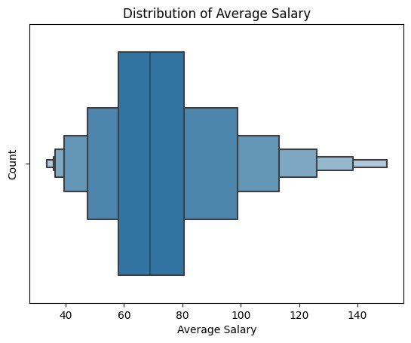

In

[14]:

*#*

*Salary*

*and*

*Job*

*Title*

data_analyst_jobs_sorted

=

data_analyst_jobs

.

sort_values(by

=

'average_salary'

,

ascending

=

False

)

plt

.

figure(figsize

=

(

12

,

6

))

sns

.

barplot(x

=

'average_salary'

,

y

=

'job_title'

,

data

=

data_analyst_jobs_sorted,

orient

=

'h'

,

order

=

data_analyst_jobs_sorted[

'job_title'

]

.

value_counts()

.

head

(

10

)

.

index)

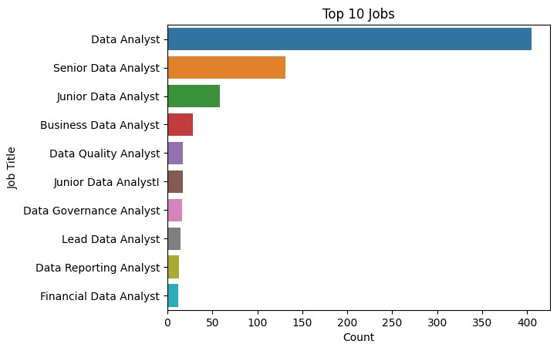

plt

.

xlabel(

'Average

Salary

(

$)'

)

plt

.

ylabel(

'Job

Title'

)

plt

.

title(

'Average

Salary

by

Job

Title'

)

plt

.

show()

5.1.1

Average

Salary

by

Job

Title

1.

Data

Analyst

2.

Senior

Data

Analyst

3.

Junior

Data

analyst

4.

Business

Data

Analyst

5.

Data

Quality

Analyst

6.

Junior

Data

Analyst

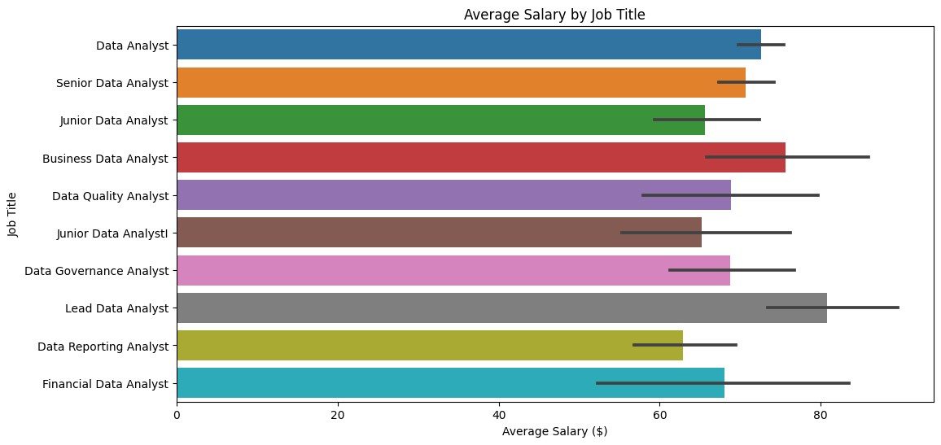

7.

Data

Governance

Analyst

8.

Lead

Data

Analyst

9.

Data

Reporting

Analyst

10.

Financial

Analyst

**Observations**

The

dataset

shows

that

there

is

a

massive

demand

for

Data

Analysts

in

the

industry.

There

is

a

huge

gap

in

job

availability

between

the

positions

of

Data

Analyst

and

Senior

Data

Analyst,

which

are

the

two

most

sought-after

positions

in

the

industry.When

it

comes

to

salary,

Data

Analysts

are

paid

on

an

average

between

60,000-80,000

per

year.

The

dataset

also

shows

that

the

highest-paying

job

in

the

industry

is

Lead

Data

Analyst,

which

pays

above

80,000

per

year

but

lacks

job

availability.

(

to

see

the

details,

please

expand)

5.2

Salary

Trends

by

Location

In

[15]:

*#salary*

*trends*

*by*

*location*

job_location

=

data_analyst_jobs

.

groupby(

'location'

)[

"average_salary"

]

.

mean()

.

reset_index()

top_10

=

job_location

.

sort_values(by

=

"average_salary"

,

ascending

=

False

)

.

head(

10

)

|  |
| --- |
| In [16]: fig = px.bar(top_10, x='average_salary', y='location', orientation='h', title='Salary Trends by Location', color =  "location") fig.update_layout(xaxis_title='AVG Salary (USD)', yaxis_title='Location', showlegend = False) fig.show()  020406080100120140Glenview, ILElk Grove Village, ILNorthfield,  ILBerkeley, CAWhittier, CAPico Rivera, CALos Gatos, CAMarin City, CADaly  City, CANewark, CA  Salary Trends by LocationAVG Salary (USD)Location  5.2.1 Top Locations Based on Average Salary  **Top 5 Locations and Headquarters**   * New York, NY * Chicago, IL * San Franciso,CA * Austin,TX * Los Angeles CA |

|  |
| --- |
| **Top 5 Locations by Salary**   * Newark, CA * Daly City, CA * Marin City, CA * Los, Gatos, CA, * Pico Rivera, CA   **Observations**  The dataset showed that the top locations and headquarters are the same. The job openings in New York is significantly higher compare to the job in Chicago.  Looking at the salary correlation the top 5 locations that has a higher salary are all located in California.  In [17]:  *# Top work locations among interviewed*  top_locations = data_analyst_jobs['location'].value_counts().head(20) sns.barplot(x=top_locations.values, y=top_locations.index)  plt.xlabel('Count') plt.ylabel('Location') plt.title('Top 20 Locations') plt.show() |

In

[18]:

top_headquarters

=

data_analyst_jobs[

'headquarters'

]

.

value_counts()

.

head(

20

)

sns

.

barplot(x

=

top_locations

.

values,

y

=

top_locations

.

index)

plt

.

xlabel(

'Count'

)

plt

.

ylabel(

'Headquarters'

)

plt

.

title(

'Top

20

Locations'

)

plt

.

show()

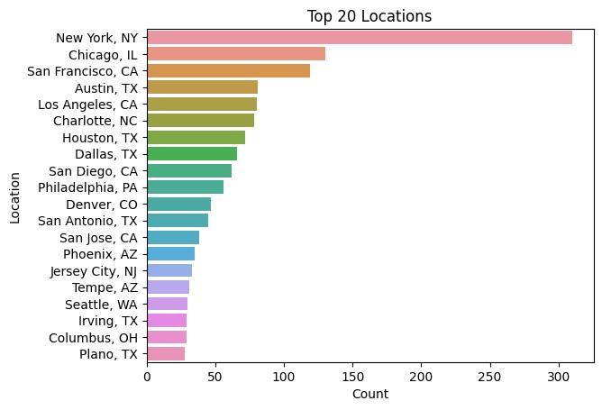

6

Company

These

are

the

focus

areas

of

the

analysis.

●

6.1

Average

Salary

by

Company

Size

●

6.2

Company

Rating

●

6.3

Type

of

Ownership

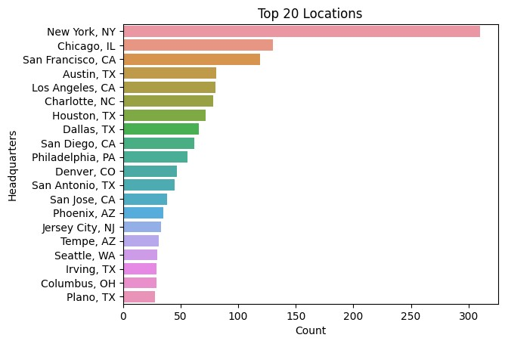

|  |
| --- |
| 6.1 Average Salary by Company Size  The company that has a biggest size which is around 5001-10000 employees has the smallest count. The company that has the highest count has around 51-200 employees. The smallest company size has a count of 350 and it's the same as the company that has around 1000 - 5000 employees. There is no significant difference between the company size and average salary in the dataset.  **Observations**  Based on the data, there are not a lot of companies that has 5000-10000 employees in the Data Analytics Industry. On the other hand the company that has more that 10000 employees has more than 350 which falls on 2nd place. The company size that has the most value counted is the company that has 51-200  In [19]:  *# Companies by Amount of Employees*  filtered_size = data_analyst_jobs[(data_analyst_jobs['size'] !=  '-1') & (data_analyst_jobs['size'] != 'Unknown')] data_analyst_jobs_size = filtered_size['size'].value_counts().head(20)  plt.figure(figsize=(10, 6)) sns.barplot(x=data_analyst_jobs_size.index, y=data_analyst_jobs_size.values) plt.xlabel('Size') plt.ylabel('Count') |

plt

.

title(

'Size

Distribution'

)

plt

.

xticks(rotation

=

90

)

plt

.

show()

In

[20]:

*#*

*Salary*

*by*

*Company*

*Size*

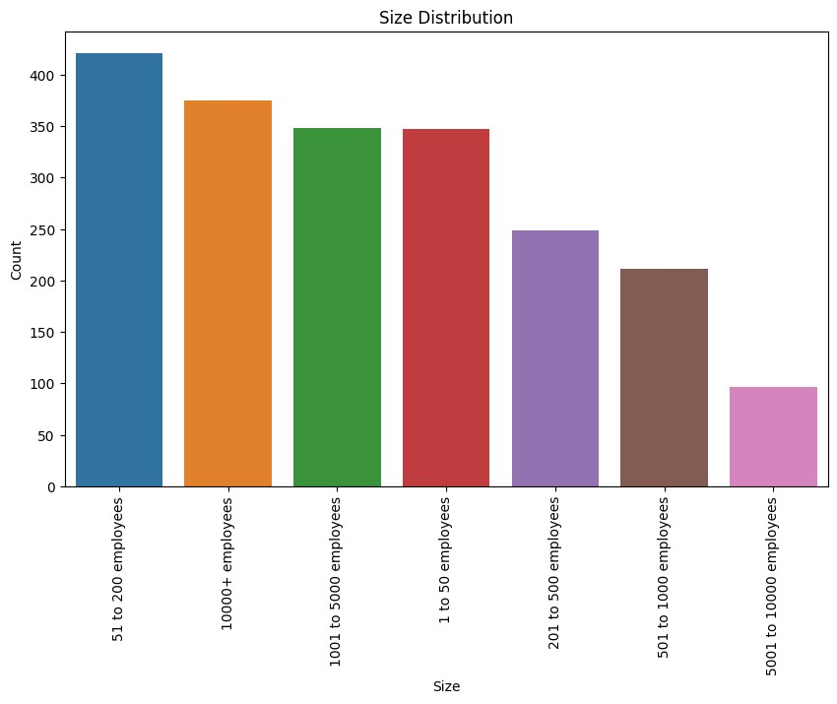

|  |
| --- |
| data_analyst_jobs_filtered = data_analyst_jobs[(data_analyst_jobs['size'] != '-1') &  (data_analyst_jobs['size'] != 'Unknown')] data_analyst_jobs_sizeXsalary = data_analyst_jobs_filtered.groupby('size')['average_salary'].me an().reset_index()  *# Sort the DataFrame by 'AverageSalary' in descending order* data_analyst_jobs_sizeXsalary = data_analyst_jobs_sizeXsalary.sort_values(by='average_salary', ascending=False)  *# Plot the bar chart* plt.figure(figsize=(12, 6)) sns.barplot(x='size', y='average_salary', data=data_analyst_jobs_sizeXsalary) plt.xlabel('Company Size') plt.ylabel('Average Salary ($)') plt.title('Average Salary by Company Size') plt.xticks(rotation=90) plt.show() |

6.2.

Company

Rating

The

rating

shows

that

the

rating

is

between

3.0-

4.0

meaning

that

there

is

a

data

analyst

jobs

rating

is

fairly

average.

In

[21]:

sns

.

boxenplot(data

=

data_analyst_jobs,

x

=

'Rating'

)

plt

.

xlabel(

'Rating'

)

plt

.

ylabel(

'Count'

)

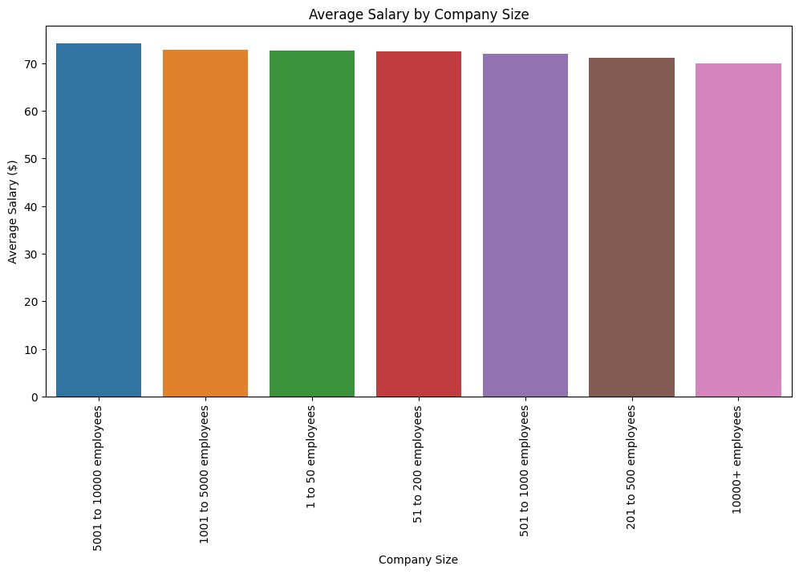

plt

.

title(

'Distribution

of

Rating'

)

plt

.

show()

6.3

Type

of

Ownership

A

significant

amount

of

data

falls

on

the

Private

sector,

followed

by

public

sector.

In

[22]:

TOP

=

data_analyst_jobs[(data_analyst_jobs[

'type_of_ownership'

]

!=

'-1'

)

&

(

data_analyst_jobs

[

'type_of_ownership'

]

!=

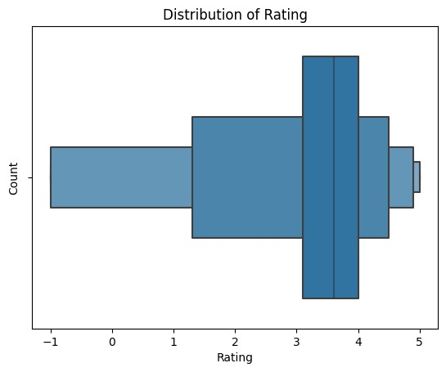

'Unknown'

)]

TOP

=

data_analyst_jobs[

'type_of_ownership'

]

.

value_counts()

.

head(

20

)

sns

.

barplot(x

=

TOP

.

values,

y

=

TOP

.

index)

plt

.

xlabel(

'Count'

)

plt

.

ylabel(

'Type

of

Ownership'

)

plt

.

title(

'Top

20

Types

of

Ownership'

)

plt

.

show()

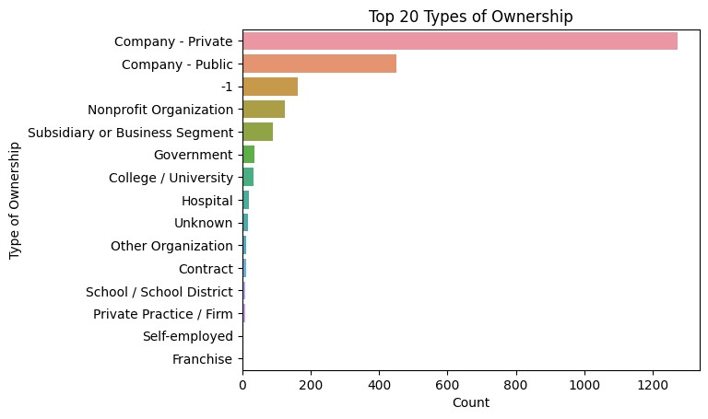

|  |
| --- |
| 1. Sector   7.1 Top Sectors  This dataset shows two sets of data. One is the top sector distribution and the other one is in correlation with the Average Salary.  **Top 5 Sectors Distribution Where Data Analyst Jobs are available**   * 1. Information Technology   2. Business Services   3. Finance   4. Health Care   5. Education   In [23]:  data_analyst_jobs_sector = data_analyst_jobs[data_analyst_jobs['sector'] !=  '-1']['sector'].value_counts().head(15)  sns.barplot(x=data_analyst_jobs_sector.values, y=data_analyst_jobs_sector.index) plt.xlabel('Count') plt.ylabel('Sector') |

plt

.

title(

'Sector

Distribution'

)

plt

.

show()

7.2

Average

Salary

by

Sector

**Top**

**Sectors**

**in**

**Correlation**

**with**

**Average**

**Salary**

1.

Biotech

&

Pharmaceuticals

2.

Real

Estate

3.

Art,

Entertainment

&

Recreation

4.

Accounting

&

Legal

5.

Information

Technology

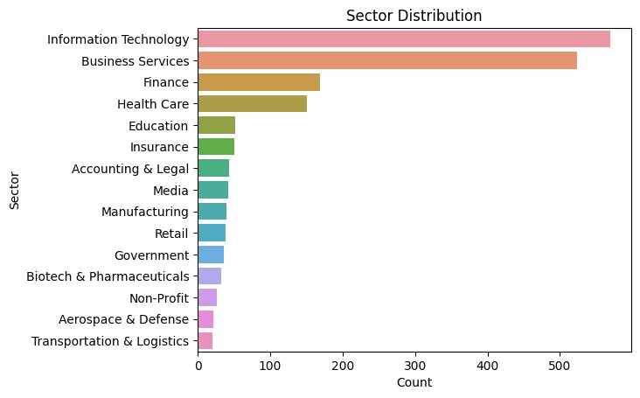

|  |
| --- |
| **Observations**  Information Technology and Business Services dominated the sector distribution. On the contrary, in correlation with the average salary, the information technology only fell at the 5th place where the average salary is between 70K-75K annually. Biotech & Pharmaceuticals showed that this sector is the highest paying sector which pays more than 80K annually.  The graph showed very distinct difference betweent the sector distribution and average salary by sector.  In [24]:  *# Salary by Sector*  average_salary_by_sector = data_analyst_jobs[data_analyst_jobs['sector'] !=  '-1'].groupby('sector')['average_salary'].mean().reset_index()  average_salary_by_sector = average_salary_by_sector.sort_values(by='average_salary', ascending=False)  plt.figure(figsize=(12, 6)) sns.barplot(x='sector', y='average_salary', data=average_salary_by_sector) plt.xticks(rotation=90) plt.xlabel('Sector') plt.ylabel('Average Salary (Thousands Dollars)') |

plt

.

title(

'Average

Salary

by

Sector'

)

plt

.

show()

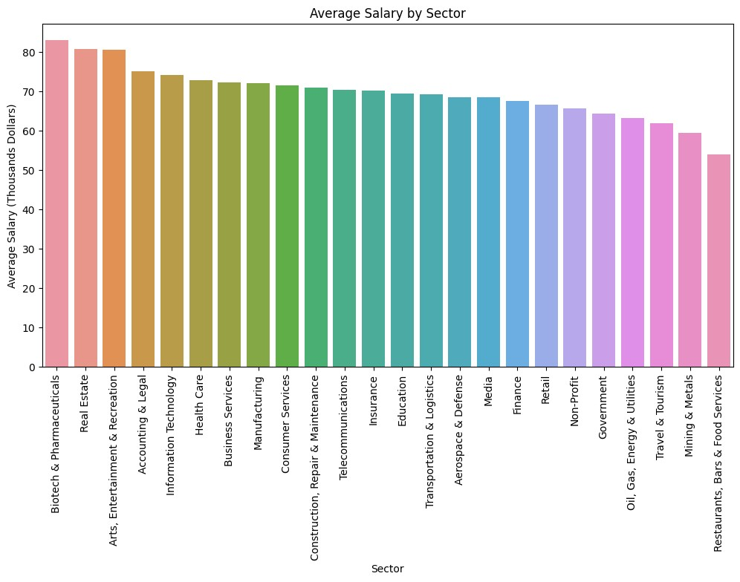

[Reference](https://github.com/MichaelAlexanderBryant/simplyhired-eda) [link](https://github.com/MichaelAlexanderBryant/simplyhired-eda)